|  |
| --- |
| Title: Sydney Airbnb Executive Summary |
| Vishesh Sagar s5247450, Hayden Baker S5278212, Zachary Hardman S51347262810ICT Software Technologies |

# **Abstract:**

# This document presents Sydney Airbnb, a sophisticated property analysis tool that provides users with comprehensive insights into real estate dynamics effortlessly. The software is designed for simplicity and accuracy and offers essential features that enable users to generate detailed reports for specific suburbs and timeframes, providing a holistic view of property listings. The dynamic charting functionality allows users to visualize price distributions and review it by cleanliness query.

# Moreover, Sydney Airbnb excels in keyword-driven searches, allowing users to retrieve records that match specific criteria, such as amenities like a pool or pet-friendly options. The software also enables users to analyze cleanliness-related comments by identifying multiple keywords associated with cleanliness factors. Search for reviews made by a specific customer name.

# **Introduction:**

# Sydney Airbnb aims to empower investors and real estate agencies in making well-informed decisions in response to the evolving real estate landscape influenced by inflation and fluctuating interest rates. Focused on the Sydney market, the app leverages insights from Airbnb datasets to provide a comprehensive tool for assessing short-term accommodation leasing trends. Real estate agencies can utilize this platform to guide investors towards profitable choices and assist homebuyers in making informed decisions about property purchases.

# This summary serves as an overview and scope document for the creation of an application under the Sydney Airbnb initiative. It outlines the project's goals and the functionality of the software. The document includes a formal distribution of work for the given timeframe, created using the Gantt Chart and Work Breakdown Structure (WBS). However, slight deviations from the original plan were identified in the software design process and app development stages.

# While the document specifies the date range covered by the data as December 17, 2018, to December 6, 2019, it states that the application will allow users to select a "user-selected period" for various analysis tasks. The actual date range will be determined by users when they interact with the application. Other user inputs will depend on the specific output they are seeking, such as finding listings in a specific suburb by providing the time range and suburb name. From a budgeting perspective, users can input the timeframe and number of suburbs to obtain mean prices for each suburb.

# The application focuses on data retrieval and visual display, allowing users to define search parameters and analyze records containing specific keywords. The technologies used to build the application include Python 3, Anaconda, Tkinter (a GUI toolkit for Python), dataframe (for database operations), and Excel (for data analysis and visualization).

# To summarize, this report establishes the foundation for the development of a software application focused on Airbnb data analysis in Sydney. Its purpose is to help real estate professionals find property details within specific suburbs and access price information.

**HOME PAGE**

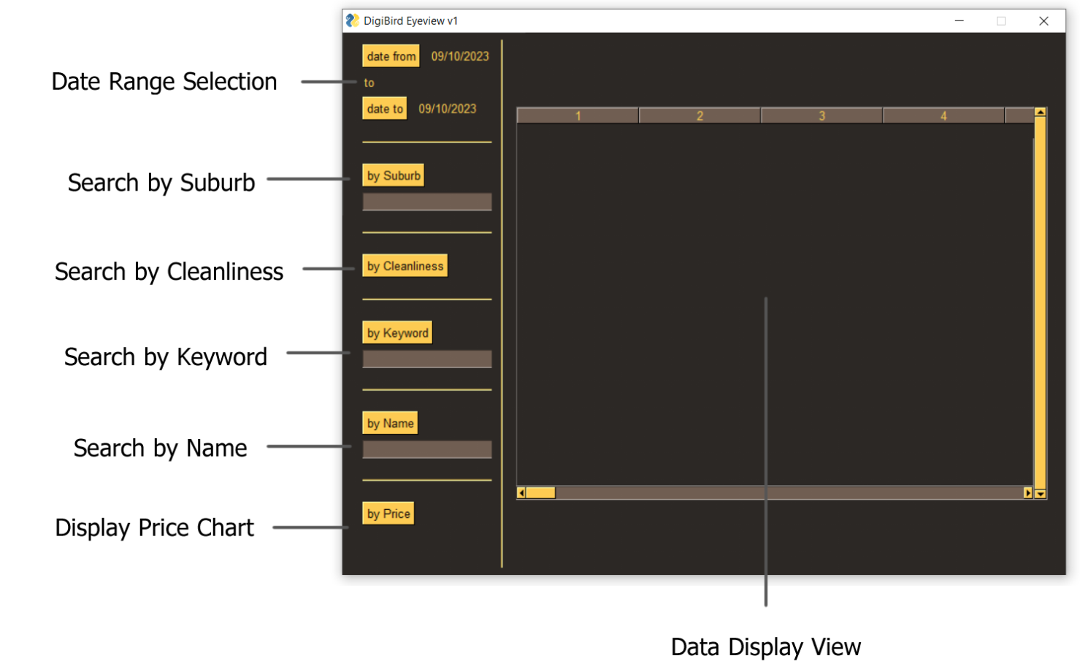

# **Analysis 1: Listings All Records**

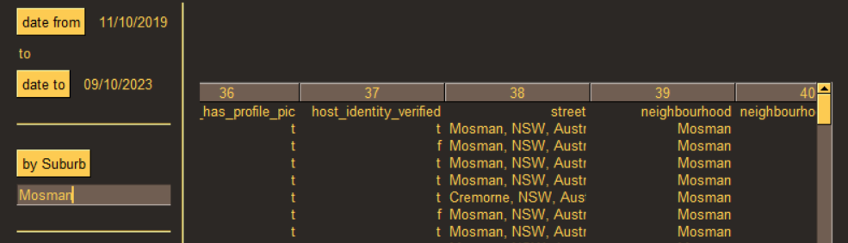

# The main objective of this feature is to provide users with comprehensive details about real estate listings in a specific suburb for their chosen timeframe. Users have access to in-depth information on the real estate market in their desired area, enabling them to make informed decisions about buying, selling, or renting homes.

# The function involves retrieving information about each property listing, including its ID, date, availability, price, URL, and scrap ID for the selected time frame. Users can customize the time range according to their needs, allowing them to analyze real estate trends over short or extended periods for specific suburbs.

# Intuitive design components like listing and URL links enhance the user experience. Effective database queries are crucial, especially when dealing with a large number of listings or a wide time range.

# **Analysis 2: Distribution of Prices of Properties**

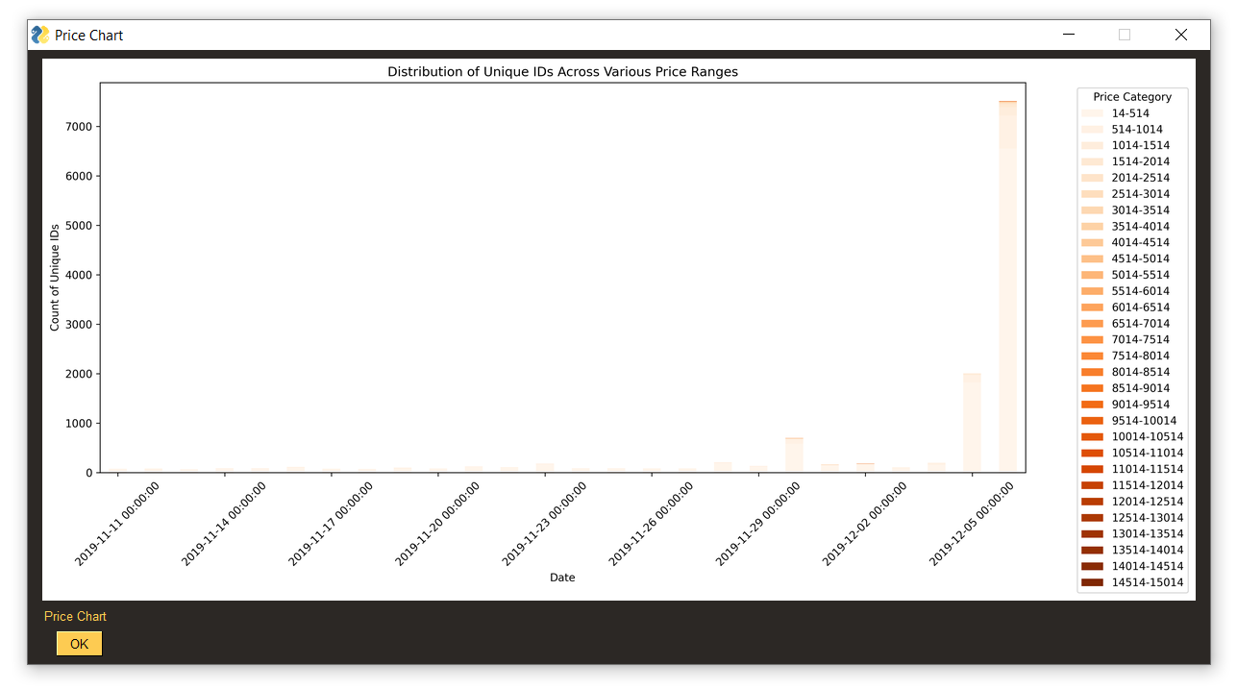

# The primary goal of this feature is to visually represent the price distribution of properties over a user-selected time span. Users can gain insights into the range, trends, and variability of property values, enhancing their understanding of the real estate market dynamics.

# The function involves compiling pricing information from real estate listings for the selected time period. The distribution of real estate values is presented on a chart, such as a histogram. The visual representation helps users comprehend the overall pricing landscape, identify typical price ranges, and identify outliers. Users can analyze how price patterns evolve by comparing distributions over different time periods for each suburb.

# The charts are designed to be aesthetically pleasing and easy to understand for users with varying levels of data analysis experience. The usability of this feature, the quality of data representation, and the clarity of user insights are key factors for its success.

# **Analysis 3: Search Keywords**

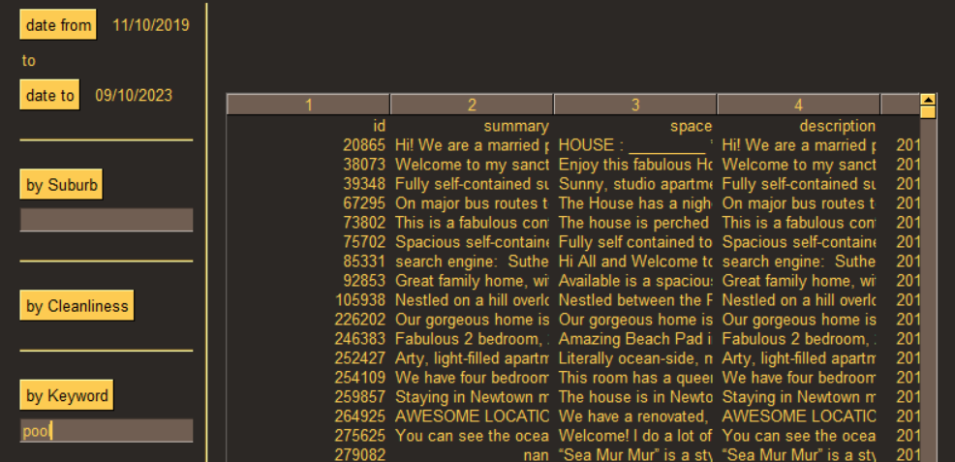

# The primary goal of this functionality is to empower users with the capability to search for and obtain real estate listings that match specific keywords, offering a specialized and thorough search experience. This functionality enables users to effortlessly discover properties that fulfill particular criteria, such as having amenities like a swimming pool or being pet-friendly.

# Within the specified time frame, the system retrieves entries that correspond to the user's specified keywords. The user interface is thoughtfully designed to be user-friendly, allowing for the easy input of keywords and delivering a transparent and uncomplicated search experience. This enables users to swiftly locate properties that align with their particular preferences, thereby enhancing their capacity to make choices in accordance with their desires.

# Overall, this feature simplifies the process of filtering listings, making the property search process more efficient and user-friendly.

# **Analysis 4: Analysis of Cleanliness-related Comments**

# 

# The objective of this analysis is to determine the number of customers who have commented on factors related to cleanliness. Cleanliness is an important aspect for customers when evaluating properties, and analyzing customer sentiments regarding cleanliness can provide valuable insights for property owners and managers.

# To perform this analysis, the software identifies multiple keywords associated with cleanliness factors, such as "clean," "tidy," "hygienic," "spotless," "sanitary," and "neat." By searching for these keywords within customer reviews, the software can determine the frequency and number of customers who have mentioned cleanliness-related factors in their comments. This analysis helps property owners and managers understand the level of importance customers place on cleanliness and make informed decisions to improve their cleaning protocols and maintain customer satisfaction.

# **Analysis 5: Reviews by Specific Customer Name**

# 

# This analysis allows users to search for reviews made by a specific customer name. By inputting a customer's name into the software, users can retrieve all the reviews associated with that particular customer. This feature is beneficial for real estate agencies and property owners who want to track and analyze feedback from specific customers.

# The software performs a search query based on the customer's name and retrieves all the reviews matching that name. Users can access and analyze the feedback provided by the specific customer, gaining insights into their preferences, experiences, and satisfaction levels. This analysis helps identify patterns, trends, and areas for improvement based on individual customer feedback, enabling personalized customer service and enhancing overall customer satisfaction.